Modified U-Net by Adding Twin Extractors for Multi-sensor Satellite Images Fusion to Map Mangrove Forest

Ilham Jamaluddin1, Ying-Nong Chen*2, Ilham Adi Panuntun3

1Graduate Student, Department of Computer Science and Information Engineering, National Central University,

No. 300, Jhongda Rd., Jhongli Dist., Taoyuan City 320317, Taiwan

Email: ilhamjamaluddin@g.ncu.edu.tw

2Assistant Professor, Center for Space and Remote Sensing Research, National Central University,

No. 300, Jhongda Rd., Jhongli Dist., Taoyuan City 320317, Taiwan

Email: yingnong1218@csrsr.ncu.edu.tw

3Graduate Student, Center for Space and Remote Sensing Research, National Central University,

No. 300, Jhongda Rd., Jhongli Dist., Taoyuan City 320317, Taiwan

Email: ilhamadipanuntun@g.ncu.edu.tw

**KEY WORDS:** mangrove, deep learning, U-Net, Sentinel-2, Sentinel-1

**ABSTRACT:** Mangrove forest is an important vegetation that has many benefits and the mangrove map is important data for many further analyses. Satellite images including optical and synthetic aperture radar (SAR) images have been widely used for mangrove forest mapping. Recently, many researchers have developed and used machine learning and deep learning algorithms for mangrove mapping using satellite imagery. U-Net is one of the deep learning semantic segmentation algorithms that is widely used for many fields including mangrove mapping and has shown promising results. The main goal of this study is to modify U-Net architecture by adding twin extractor parts that will be used for multi-sensor satellite image fusion. We used optical satellite images (Sentinel-2) and SAR satellite images (Sentinel-1). The twin extractor parts will extract the information from optical and SAR images separately and then fuse the extracted features using concatenated layer, after that the fused features will be fed to the U-Net architecture. We adopted the inception module for the twin extractor part. The study area is located in the coastal zone of Rookery Bay, Florida, USA. The target data (mangrove and non-mangrove) for this study was collected by visual interpretation based on reference data from the global mangrove watch. We compare our modified U-Net with the original U-Net architecture in the evaluation process, we just combine the Sentinel-2 and Sentinel-1 data together for the original U-Net architecture input. Based on the experiment results, the modified U-Net and the original U-Net has intersection over union (IoU) score of mangrove class of 0.9404 and 0.9333, respectively. While the F1-score of the mangrove class from modified U-Net and original U-Net are 0.9693 and 0.9655, respectively. Based on this result, by adding the fusion twin extractor parts in the U-Net architecture can improve the performance of mangrove mapping using optical and SAR imagery.

# Introduction

Mangroves have many benefits such as biodiversity conservation and carbon storage vegetation (Carugati et al., 2018; T. Hu et al., 2020). Mangroves also considered as the blue carbon ecosystem that prevent the climate change (Zhu & Yan, 2022). Due to the benefits of mangrove forest, the accurate and effective of mangrove mapping is needed. The main challenge of mangrove mapping is to deal with the condition of mangrove forests because mangroves are dynamic ecosystems (Ximenes et al., 2023). Remote sensing satellite imagery is one of the data sources that is widely used for mangrove mapping due to the temporal and large area availability (Giri, 2021).

In the recent years, the combination of optical and SAR imagery has been used for mangrove mapping and achieved favourable result (Ghorbanian et al., 2021; Huang et al., 2022; L. Hu et al., 2020; Monzon et al., 2016). The optical satellite imagery such as Sentinel-2 is sensitive to the biophysical features (e.g., leaf chlorophyll and water content) of vegetation, while the SAR imagery such as Sentinel-1 is can penetrate clouds and may be useful for mangrove mapping (L. Hu et al., 2020). SAR is responsive to the moisture content and surface roughness (Hosseiny et al., 2022). The use of a combination of optical and SAR imagery improved the model performance more compared to just using optical or SAR images individually(L. Hu et al., 2020).

Recently, deep learning algorithms have widely used in remote sensing field including for mangrove mapping (M. Guo et al., 2021; Ma et al., 2019). Fully convolutional network (FCN) for semantic segmentation tasks including mangrove mapping has gotten more attention due to their benefits that can effectively be used for large-area satellite imagery (M. Guo et al., 2021; Y. Guo et al., 2021; Jamaluddin et al., 2021). One of the semantic segmentation architectures that has promising performance for satellite imagery pixel classification is U-Net (Li et al., 2021; Zhang et al., 2021). U-Net originally proposed for biomedical image segmentation and opened the possibility to use for other research field (Ronneberger et al., 2015).

Previous study used machine learning technique such as random forest for mangrove mapping using Sentinel-2 and Sentinel-1 imagery and achieved favourable result (Ghorbanian et al., 2021; L. Hu et al., 2020). The use of deep learning semantic segmentation such as U-Net for mangrove mapping using multi-sensor satellite imagery needs further investigation. Optical satellite imagery (Sentinel-2) and SAR imagery (Sentinel-1) were used in this study. Feeding the optical and SAR imagery to the U-Net model needs further attention to improve the U-Net model performance. Based on the background mentioned above, our goal is to modify U-Net architecture for mangrove mapping by adding the fusion extractor part for optical and SAR imagery. The fusion extractor part will extract the feature information from Sentinel-2 and Sentinel-1 separately and then fuse the extracted features as the input for the U-Net model. The rest of this paper is organized as follows: the study area and materials are discussed in Section 2, methods are discussed in Section 3, result and discussions are discussed in Section 4, and conclusion is written in Section 5.

# Study area and Materials

## Study area

The study area located in the coastal zone of Rookery Bay, Florida, United States of America (USA) (Figure 1). The center coordinate location of this study is 25°56'34.51"N and 81°36'52.52"W and has the total area of 1353.31 km2. We divided the study area become two parts: 1) is the whole study area and 2) is the training area that shows in the purple box. The Training area also consists of the visually interpreted ground truth label as the target data. There are three mangrove species along the study area, namely *Rhizophora mangle*, *Laguncularia racemosa*, and *Avicennia germinans*(Mccarthy et al., 2020). This study is located in the sub-tropical climate zone.

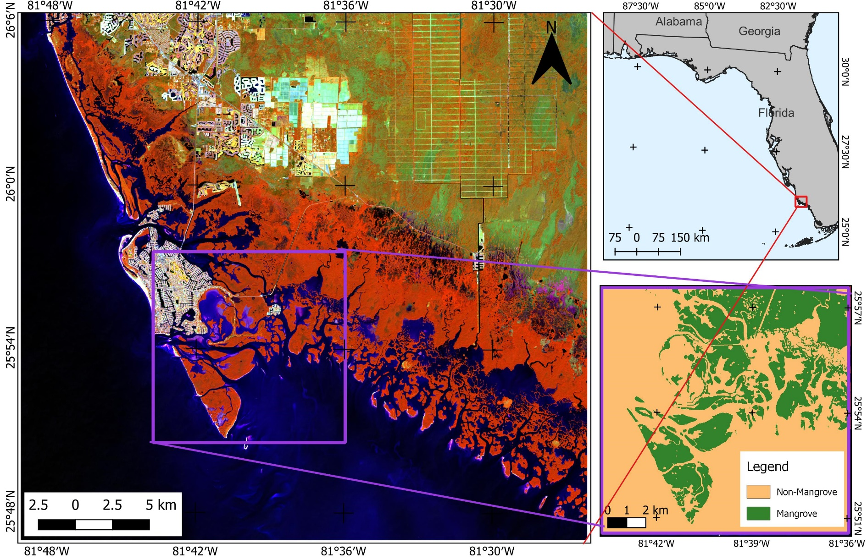

Figure 1. Study area and visually interpreted ground truth label

## Materials

### Sentinel-2

Sentinel-2 is freely available remote sensing data provided by the European Space Agency (ESA). We downloaded the Level-1C product (top-of-atmosphere with radiometric and geometric correction on a global reference system product) and then corrected it to the bottom-of-atmosphere data. We adopted the combination of Sentinel-2 original bands and spectral indices for mangrove mapping based on the previous study (Jamaluddin et al., 2021). The previous study uses 10 input bands from Sentinel-2: blue, green, red, near-infrared (NIR), shortwave infrared (SWIR) 1, and SWIR 2, normalized difference vegetation index (NDVI), combined mangrove index (CMRI), normalized difference mangrove index (NDMI), and modified mangrove recognition index (MMRI). First, we resampled the SWIR-1 and SWIR-2 bands to become a 10-meter spatial resolution to ensure all of the bands have the same spatial resolution. Next, we produced all of the spectral indices by using their spectral indices formula. The NDVI, CMRI, NDMI, and MMRI formulas are shown in Table 1. In total, we have 10 bands for the Sentinel-2 image.

Table 1. Sentinel-2 spectral indices formula

|  |  |  |
| --- | --- | --- |
| **Spectral Indices** | **Formula** | **References** |
| NDVI | $$\frac{(NIR-Red)}{\left(NIR+Red\right)}$$ | (Tucker, 1979) |
| CMRI | $$\left(\frac{\left(NIR-Red\right)}{\left(NIR+Red\right)}\right)-\left(\frac{\left(Green-NIR\right)}{\left(Green+NIR\right)}\right)$$ | (Gupta et al., 2018) |
| NDMI | $$\frac{(SWIR2-Green)}{\left(SWIR2+Green\right)}$$ | (Shi et al., 2016) |
| MMRI |  | (Diniz et al., 2019) |

### Sentinel-1

Same as Sentinel-2, Sentinel-1 is also a freely available C-band SAR image provided by the ESA. Sentinel-1 is the dual-polarized C-band sensor that has the capability to penetrate through cloud, soil, and vegetation canopies (Hosseiny et al., 2022). We use google earth engine (GEE) to download the Sentinel-1 image Level-1C Ground Range Detected (GRD). We use dual polarized VV and VH Sentinel-1 images: $σ_{VV}$ (vertical transmits and vertical receive) and $σ_{VH}$ (vertical transmits and horizontal receives) backscattering coefficient. In total, we have 2 bands for the Sentinel-1 image.

### Visually interpreted ground truth label

The deep learning model that used in this study is supervised semantic segmentation scheme, so we need target data for training the model. To obtain the target data for model training, we use visually interpretation analysis by using Sentinel-2 image and the supporting data from global mangrove watch (Bunting et al., 2018). We use the term of visual interpreted ground truth label as our target data. To visually distinguish the mangrove object from other objects, we first use the false color composite (NIR-SWIR-Red) that can enhance the mangrove object. We also use the mangrove spectral indices such as CMRI, NDMI, and MMRI to help us distinguish mangrove objects. In total, the visual interpreted target data that used in this study has total area of 167.82 km2 with the image shape of 1298 x 1292 pixels (with 10-m spatial resolution). Since our model is binary semantic segmentation, we only have 2 classes which is mangrove and non-mangrove class. The visual interpreted target data can be seen in Figure 1 in the purple box.

# Methods

The workflow of this study was divided into two main sections, the first one is for the model training process and the second one is for the mapping process (Figure 2). The visual interpreted target data, Sentinel-2, and Sentinel-1 in the training area were firstly patched to become small patches (32 x 32) to make it easier to feed them into the model. Then, we split the small-patches data becomes training (80%) and testing (20%) datasets. For training purposes, we divided the training data becomes 80% for training and 20% for validation data. We use the training and validation data as our input modified U-Net model. After we get the trained modified U-Net model, we use the testing dataset (never seen during training) to evaluate our model performance by using the intersection over union (IoU) score and F1-score. For the second section (mapping process), we firstly mask the Sentinel-2 and Sentinel-1 image based on the coastal zone area. Then, we do the same patched pre-processing data for the Sentinel-2 and Sentinel-1 data in the whole study area. Then, the patched images will be fed to the trained modified U-Net model to generate the mangrove map in the whole study area. We also collected another independent reference point for map accuracy assessment purposes.



Figure 2. Workflow for this study

## Modified U-Net

The modified U-Net architecture is shown in Figure 3. In general, we added twin extractor multi-sensor satellite image fusion and then fed the fused extracted features to the U-Net model. U-Net has a symmetric U-shape and consists of downsample part or constructing path and upsample part or expensive path (Ronneberger et al., 2015). The downsample part is used to capture the contextual information, this part is also known as the U-Net backbone. While the upsample part is used to detail localization and re-construct the shape of the feature maps. U-Net introduces skip connections to their architecture that can learn low-level details and high-level context by concatenating the layers in downsample and upsample parts.

We introduce a twin extractor multi-sensor satellite image fusion that has the ability to learn the information from optical image (Sentinel-2) and SAR image (Sentinel-1) separately, then concatenate the extracted output feature maps to fuse the information from optical and SAR image. The twin extractor map adopted the inception module from the inception network (Szegedy et al., 2015). The main advantage of the inception module is overcoming the overfitting and the computational cost problem because the inception module uses a 1 x 1 convolutional layer at the first stage before 3 x 3 and 5 x 5 convolution layers. The detailed inception model that we use for the twin extractor part is shown in Figure 4. In the beginning, the inception module has one 1 x 1 convolution that directly fed into the concatenation stage, two 1 x 1 convolutions that fed to 3 x 3 and 5 x 5 convolutions before fed to the concatenation stage, and a max-pooling layer that fed to the 1 x 1 convolution before fed to the concatenation stage. In the inception module, each 2D convolutional was followed by ReLU and batch normalization. The concatenation stage will be the final output from the inception module.

In the twin extractor part, we use the same exact inception module to exploit the information both from Sentinel-2 and Sentinel-1 images. Then the extracted feature maps from the Sentinel-2 inception module and Sentinel-1 inception module will be concatenated and fed to the U-Net backbone. We implement ResNet 34 as our U-Net backbone architecture (He et al., 2016). Then for the final output of our modified U-Net, we use sigmoid as the activation function since our goal is a binary segmentation task (mangrove and non-mangrove).

downsample

upsample

concatenate (skip connection)

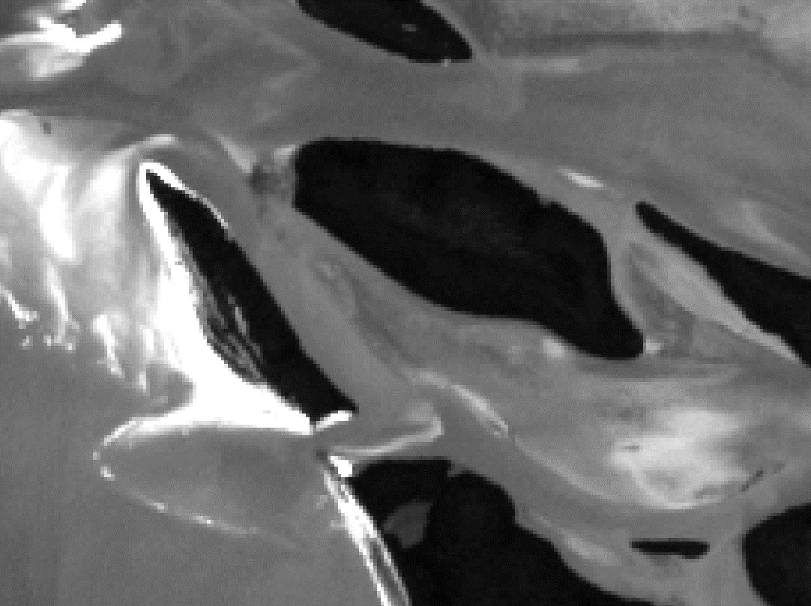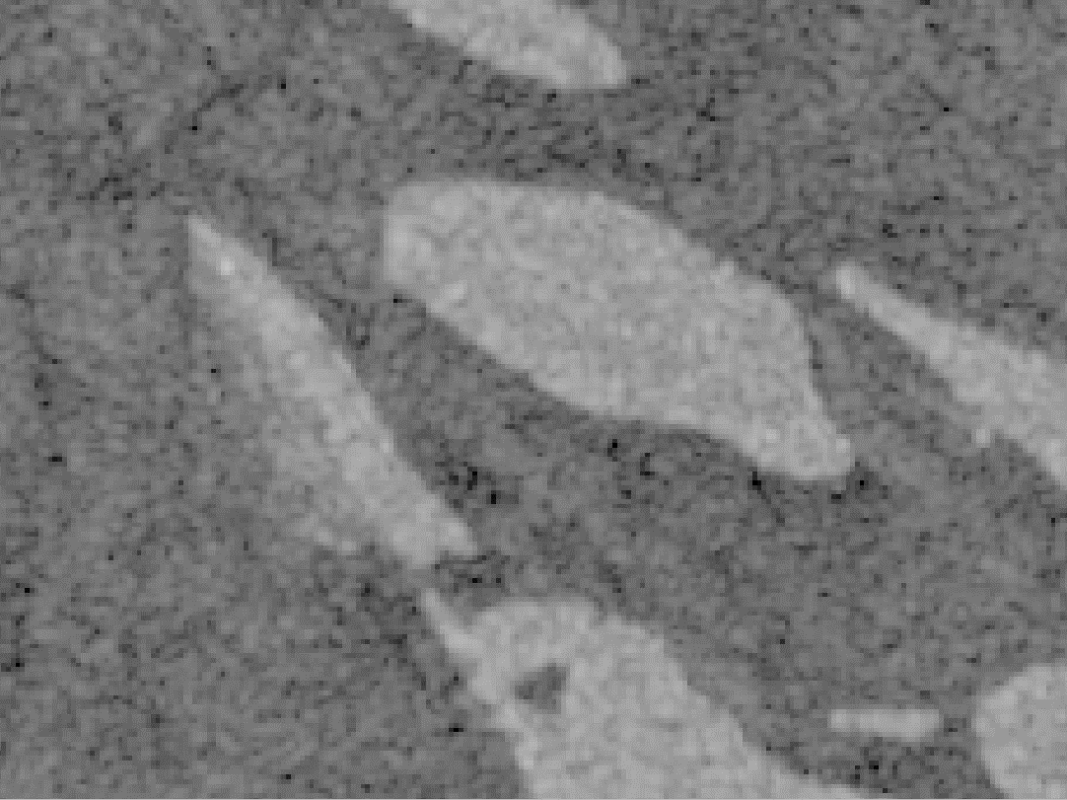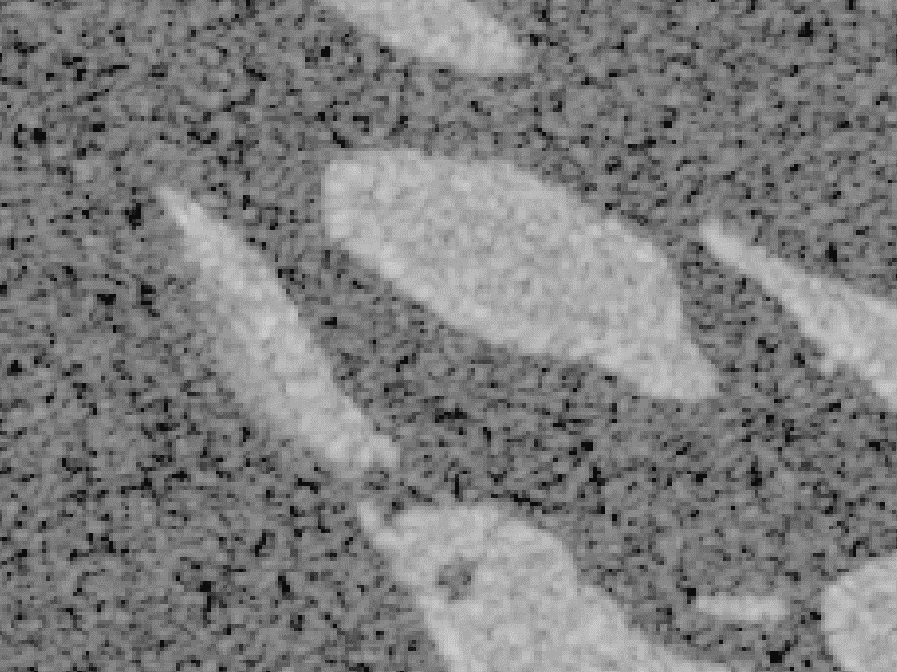

Sentinel-1

(32 x 32 x 2)

Sentinel-2

(32 x 32 x 10)

Inception Module

Inception Module

**Twin Extractor**

**U-Net**

: concatenation

Figure 3. Modified U-Net architecture

Satellite image patch

Output feature maps

: Max Pooling

: 2D Convolution

Figure 4. Inner structure of inception module

## Evaluation Assessments

As mentioned before in the workflow stage, we divided our works into two main section, the model training process and mangrove mapping process. To evaluate the modified U-Net model, we have two evaluation assessments such as model output evaluation (Section 3.2.1) and mangrove map accuracy assessment (Section 3.2.2). We also compare the modified U-Net with the original U-Net, random forest (RF) and decision tree (DT) for model evaluation. For the original U-Net, RF, and DT, we just combine the Sentinel-2 and Sentinel-1 data together as the input data.

### Model evaluation

The model evaluation aims to evaluate the modified U-Net performance. We use the testing dataset that never seen during training to evaluate the model. We calculated two metrics for the model evaluation: 1) intersection over union (IoU) and 2) F1-score. The IoU score is common evaluation metrics for semantic segmentation task that divide the area of union between the visually interpreted label and the predicted output by the area overlap between the two. The IoU score calculated with the following equation (1):

|  |  |
| --- | --- |
|  | (1) |

While the F1-score is the harmonic mean of precision and recall that calculated with the following equation (2):

|  |  |
| --- | --- |
| $$F1Score= 2 x \frac{\sum_{i=1}^{C}{\left(\left(\frac{{TP}_{i}}{{TP}_{i} + {FP}_{i}}\right) x \left(\frac{{TP}_{i}}{{TP}_{i}+{FN}_{i}}\right)\right)}}{\sum_{i=1}^{C}{\left(\left(\frac{{TP}_{i}}{{TP}_{i} + {FP}_{i}}\right) + \left(\frac{{TP}_{i}}{{TP}_{i} +{FN}_{i}}\right)\right)}}$$ | (2) |

where TP, FP, FN, and C represents the true positive, false positive, false negative, and number of class, respectively.

### Map accuracy assessment

The second section of this study is to produce the mangrove map in the whole study area using modified U-Net model. We collected another 600 reference points (300 for mangrove and 300 for non-mangrove) based on the Sentinel-2 image and google earth image (Figure 5). We calculated the precision, recall, F1-score, and kappa score to know the quality of the produced mangrove map. The recall was calculated with the following equation (3):

|  |  |
| --- | --- |
| $$Recall=\frac{TP}{TP+FN}$$ | (3) |

While the precision was calculated with the following equation (4):

|  |  |
| --- | --- |
| $$Precision=\frac{TP}{TP+FP}$$ | (4) |

Finally, the kappa score was calculated to understand the agreement between 2 classes using the following equation (5):

|  |  |
| --- | --- |
| $$Kappa=\frac{P_{agree}-P_{chance}}{1-P_{chance}}$$ | (4) |

where $P_{agree}$ and $P_{chance}$ represents the proportion of correct classification and proportion of chance agreement, respectively.

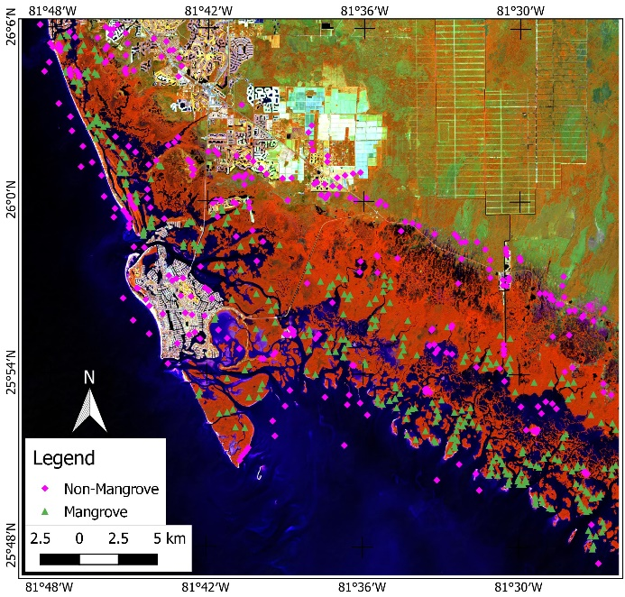

Figure 5. Reference point for map accuracy assessment

## Training Details

The modified U-Net model was trained thrice to calculate the average performance result. We performed an early stopping scheme to prevent the overfitting problem by using a validation dataset during the training process with 20 epochs of patience. We use a learning rate schedule, Adam as our optimizer, and binary cross entropy as the loss function. Then we set the batch size of 16. The model was constructed and trained using Keras in Tensorflow provided by Google in Python. The U-Net model was constructed using segmentation_models (github.com/qubvel/segmentation_models). The Python code was executed on a Windows 10 platform with an Intel Core i9-11900K CPU, NVIDIA GeForce RTX 3090 GPU, and 64 GB of RAM.

# result and discussions

## Modified U-Net Result

The modified U-Net was trained using an early-stopping scheme. The model training loss for training and validation data is shown in Figure 6. Based on the training and validation loss, the modified U-Net successfully learns the spatial-spectral information from Sentinel-2 and Sentinel-1 imageries for mangrove pixel-based classification. The loss curve decreased steadily indicating that the predicted output from the modified U-Net model is close to the visual interpreted target data. While, based on the model output evaluation assessment using the testing dataset, the modified U-Net has an average mean IoU and F1-score of 0.9573 and 0.9816, respectively. The IoU and F1-score of the mangrove class are 0.9404 and 0.9693, respectively. The model evaluation assessment shows the modified U-Net has promising results.

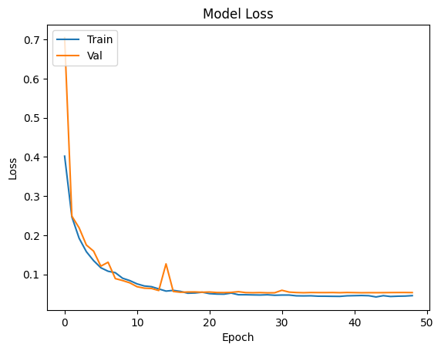

Figure 6. Modified U-Net training and validation loss.

## Comparison with other models

The comparison results with the original U-Net and some machine learning algorithms (e.g. random forest (RF) and decision tree (DT)) were conducted to determine the overall performance of the modified U-Net (Table 2). We use the same U-Net architecture as the comparison to ensure that adding the twin extractor part will increase the U-Net model performance or not. Based on the experiment results, the modified U-Net outperformed the original U-Net and some machine learning techniques in terms of IoU and F1-score. Based on the IoU score, the modified U-Net surpasses the original U-Net by 0.71%, that means adding the twin extractor part improved the model performance. While, the RF also has good performance for mangrove mapping but still lower than the modified U-Net. The DT result has the lowest performance with the IoU score difference between modified U-Net was 3.28%.

Table 2. Comparison of IoU and F1-score for mangrove and non-mangrove classes based on testing dataset

|  |  |  |  |  |
| --- | --- | --- | --- | --- |
| **Model** | **IoU Mangrove** | **IoU Non-Mangrove** | **F1-Score Mangrove** | **F1-Score Non-Mangrove** |
| **Modified U-Net** | **0.9404** | **0.9741** | **0.9693** | **0.9869** |
| U-Net | 0.9333 | 0.9708 | 0.9655 | 0.9851 |
| RF (150 trees) | 0.9372 | 0.9729 | 0.9675 | 0.9862 |
| RF (100 trees) | 0.9371 | 0.9728 | 0.9862 | 0.9675 |
| DT | 0.9076 | 0.9600 | 0.9517 | 0.9796 |

Besides the model evaluation assessment using the IoU and F1-score, we also conducted the model efficiency evaluation based on average training time, second per epoch (SPE), and total trainable parameters (Table 3). Based on the experiment results, the modified U-Net and the original U-Net have the same average training time (2 minutes 29 seconds), while the modified U-Net has a better SPE time than the original U-Net. The reasonable reason is that we use the inception module to construct the twin extractor part which will reduce the complexity of the model. In terms of total trainable parameters, the modified U-Net has slightly more parameters than the original U-Net. If we compare with the RF model, the modified U-Net has a better average training time because the modified U-Net was run in the GPU while the RF was run in the CPU. The DT has the average training time due to the simplest model.

Table 3. Comparison of mean IoU, overall accuracy, average training time, and second per-epoch based on testing dataset

|  |  |  |  |  |  |
| --- | --- | --- | --- | --- | --- |
| **Model** | **Mean IoU** | **Overall Accuracy** | **Training Time (mm:ss)** | **Seconds Per-Epoch (SPE)** | **Trainable Parameters** |
| **Modified U-Net** | **0.9573** | **0.9816** | **02:29** | **0.297 seconds** | **24,840,369** |
| U-Net | 0.9520 | 0.9792 | 02:29 | 0.337 seconds | 24,467,037 |
| RF (150 trees) | 0.9550 | 0.9807 | 07:33 | - | - |
| RF (100 trees) | 0.9549 | 0.9806 | 04:52 | - | - |
| DT | 0.9339 | 0.9713 | 00:13 | - | - |

We also conducted the visual analysis to know the visual performance of the output results from the modified U-Net model, original U-Net, RF with 150 trees, RF with 100 trees, and DT algorithm (Figure 7). Based on the visual analysis result, all of the models have promising results. When we take a look at more detail, the modified U-Net result has more detail results compared with other models. We found the RF and DT results have some pixel noise, this is related to the RF and DT works in vector operation that didn’t consider the neighbourhood pixel. In general, the modified U-Net outperformed the other models both on the model evaluation assessment and visual analysis.

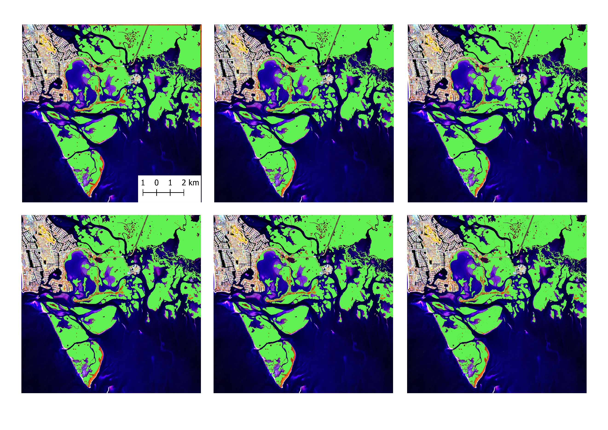

a)

b)

c)

d)

e)

f)

Figure 7. Visual analysis for mangrove mapping. a) Visual interpreted ground truth, b) modified U-Net, c) original U-Net, d) RF with 150 trees, e) RF with 100 trees, and f) DT algorithm.

## Mangrove map for whole study area

The second goal of this study is to map mangroves in the whole study area using the trained modified U-Net model. We successfully map mangrove forests in the coastal zone of Rookery Bay, Florida (Figure 8). Based on our result, the total mangrove area in the study area is 242.84 km2. As we can see, the mangrove is located along the coastal zone. Some of the mangroves also grow near the town. We calculate the map accuracy assessment based on independent reference points to know the quality of the produced mangrove map (Table 4). Based on the accuracy assessment result, the produced mangrove map from the modified U-Net model has a promising result. The overall score of the mangrove map is 0.9867, while the F1-score of the mangrove class is 0.9865. Based on our calculation, the kappa score of the mangrove map is 0.9733 and is included in the almost perfect agreement category.

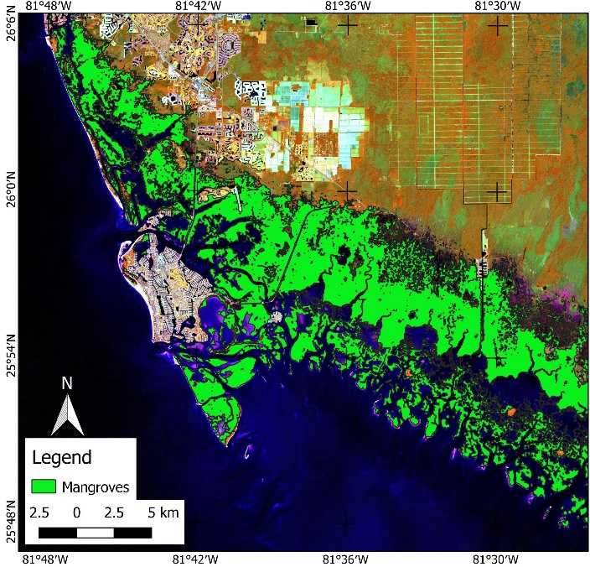

Figure 8. Mangrove map in whole study area based on trained Modified U-Net model

Table 4. Map accuracy assessment based on independent reference points

|  |  |  |  |
| --- | --- | --- | --- |
| **Class** | **Precision** | **Recall** | **F1-Score** |
| Non-Mangrove | 0.9966 | 0.9767 | 0.9865 |
| Mangrove | 0.9771 | 0.9967 | 0.9868 |

# Conclusions

Using the combination of optical and SAR imagery for mangrove mapping can improve the mapping result. This study modified the U-Net model by adding the twin extractor part for multi-sensor satellite image fusion. This study uses Sentinel-2 and Sentinel-1 images for mangrove mapping. Based on the experiment result, the modified U-Net outperformed the original U-Net model and some machine learning techniques in terms of model evaluation and visual analysis results. The trained modified U-Net model was used to produce a mangrove map in the whole study area with an overall accuracy of the mangrove map is 0.9867, while the F1-score of the mangrove class was 0.9865.

# References

Bunting, P., Rosenqvist, A., Lucas, R. M., Rebelo, L. M., Hilarides, L., Thomas, N., Hardy, A., Itoh, T., Shimada, M., & Finlayson, C. M. (2018). The global mangrove watch - A new 2010 global baseline of mangrove extent. *Remote Sensing*, *10*(10), 1669. https://doi.org/10.3390/rs10101669

Carugati, L., Gatto, B., Rastelli, E., Lo Martire, M., Coral, C., Greco, S., & Danovaro, R. (2018). Impact of mangrove forests degradation on biodiversity and ecosystem functioning. *Scientific Reports*, *8*(1). https://doi.org/10.1038/s41598-018-31683-0

Diniz, C., Cortinhas, L., Nerino, G., Rodrigues, J., Sadeck, L., Adami, M., & Souza-Filho, P. W. M. (2019). Brazilian mangrove status: Three decades of satellite data analysis. *Remote Sensing*, *11*(7). https://doi.org/10.3390/rs11070808

Ghorbanian, A., Zaghian, S., Asiyabi, R. M., Amani, M., Mohammadzadeh, A., & Jamali, S. (2021). Mangrove ecosystem mapping using sentinel-1 and sentinel-2 satellite images and random forest algorithm in google earth engine. *Remote Sensing*, *13*(13). https://doi.org/10.3390/rs13132565

Giri, C. (2021). Recent advancement in mangrove forests mapping and monitoring of the world using earth observation satellite data. In *Remote Sensing* (Vol. 13, Issue 4). https://doi.org/10.3390/rs13040563

Guo, M., Yu, Z., Xu, Y., Huang, Y., & Li, C. (2021). Me-net: A deep convolutional neural network for extracting mangrove using sentinel-2A data. *Remote Sensing*, *13*(7). https://doi.org/10.3390/rs13071292

Guo, Y., Liao, J., & Shen, G. (2021). Mapping large-scale mangroves along the maritime silk road from 1990 to 2015 using a novel deep learning model and landsat data. *Remote Sensing*, *13*(2), 245. https://doi.org/10.3390/rs13020245

Gupta, K., Mukhopadhyay, A., Giri, S., Chanda, A., Datta Majumdar, S., Samanta, S., Mitra, D., Samal, R. N., Pattnaik, A. K., & Hazra, S. (2018). An index for discrimination of mangroves from non-mangroves using LANDSAT 8 OLI imagery. *MethodsX*, *5*. https://doi.org/10.1016/j.mex.2018.09.011

Hosseiny, B., Mahdianpari, M., Brisco, B., Mohammadimanesh, F., & Salehi, B. (2022). WetNet: A Spatial–Temporal Ensemble Deep Learning Model for Wetland Classification Using Sentinel-1 and Sentinel-2. *IEEE Transactions on Geoscience and Remote Sensing*, *60*, 1–14. https://doi.org/10.1109/TGRS.2021.3113856

Huang, K., Yang, G., Yuan, Y., Sun, W., Meng, X., & Ge, Y. (2022). Optical and SAR images Combined Mangrove Index based on multi-feature fusion. *Science of Remote Sensing*, *5*. https://doi.org/10.1016/j.srs.2022.100040

Hu, L., Xu, N., Liang, J., Li, Z., Chen, L., & Zhao, F. (2020). Advancing the mapping of mangrove forests at national-scale using Sentinel-1 and Sentinel-2 time-series data with Google Earth Engine: A case study in China. *Remote Sensing*, *12*(19). https://doi.org/10.3390/RS12193120

Hu, T., Zhang, Y. Y., Su, Y., Zheng, Y., Lin, G., & Guo, Q. (2020). Mapping the global mangrove forest aboveground biomass using multisource remote sensing data. *Remote Sensing*, *12*(10). https://doi.org/10.3390/rs12101690

Jamaluddin, I., Thaipisutikul, T., Chen, Y. N., Chuang, C. H., & Hu, C. L. (2021). Mdprepost-net: A spatial-spectral-temporal fully convolutional network for mapping of mangrove degradation affected by hurricane irma 2017 using sentinel-2 data. *Remote Sensing*, *13*(24), 5042. https://doi.org/10.3390/rs13245042

Li, H., Wang, C., Cui, Y., & Hodgson, M. (2021). Mapping salt marsh along coastal South Carolina using U-Net. *ISPRS Journal of Photogrammetry and Remote Sensing*, *179*. https://doi.org/10.1016/j.isprsjprs.2021.07.011

Ma, L., Liu, Y., Zhang, X., Ye, Y., Yin, G., & Johnson, B. A. (2019). Deep learning in remote sensing applications: A meta-analysis and review. In *ISPRS Journal of Photogrammetry and Remote Sensing* (Vol. 152, pp. 166–177). https://doi.org/10.1016/j.isprsjprs.2019.04.015

Mccarthy, M. J., Jessen, B., Barry, M. J., Figueroa, M., Mcintosh, J., Murray, T., Schmid, J., & Muller-Karger, F. E. (2020). Automated high-resolution time series mapping of mangrove forests damaged by hurricane irma in Southwest Florida. *Remote Sensing*, *12*(11). https://doi.org/10.3390/rs12111740

Monzon, A. K., Reyes, S. R., Veridiano, R. K., Tumaneng, R., & De Alban, J. D. (2016). SYNERGY OF OPTICAL AND SAR DATA FOR MAPPING AND MONITORING MANGROVES. *The International Archives of the Photogrammetry, Remote Sensing and Spatial Information Sciences*, *XLI-B6*. https://doi.org/10.5194/isprs-archives-xli-b6-259-2016

Ronneberger, O., Fischer, P., & Brox, T. (2015). U-net: Convolutional networks for biomedical image segmentation. *Lecture Notes in Computer Science (Including Subseries Lecture Notes in Artificial Intelligence and Lecture Notes in Bioinformatics)*, *9351*. https://doi.org/10.1007/978-3-319-24574-4_28

Shi, T., Liu, J., Hu, Z., Liu, H., Wang, J., & Wu, G. (2016). New spectral metrics for mangrove forest identification. *Remote Sensing Letters*, *7*(9). https://doi.org/10.1080/2150704X.2016.1195935

Szegedy, C., Liu, W., Jia, Y., Sermanet, P., Reed, S., Anguelov, D., Erhan, D., Vanhoucke, V., & Rabinovich, A. (2015). Going deeper with convolutions. *Proceedings of the IEEE Computer Society Conference on Computer Vision and Pattern Recognition*, *07-12-June-2015*. https://doi.org/10.1109/CVPR.2015.7298594

Tucker, C. J. (1979). Red and photographic infrared linear combinations for monitoring vegetation. *Remote Sensing of Environment*, *8*(2). https://doi.org/10.1016/0034-4257(79)90013-0

Ximenes, A. C., Cavanaugh, K. C., Arvor, D., Murdiyarso, D., Thomas, N., Arcoverde, G. F. B., Bispo, P. da C., & Van der Stocken, T. (2023). A comparison of global mangrove maps: Assessing spatial and bioclimatic discrepancies at poleward range limits. *Science of the Total Environment*, *860*. https://doi.org/10.1016/j.scitotenv.2022.160380

Zhang, H., Liu, M., Wang, Y., Shang, J., Liu, X., Li, B., Song, A., & Li, Q. (2021). Automated delineation of agricultural field boundaries from Sentinel-2 images using recurrent residual U-Net. *International Journal of Applied Earth Observation and Geoinformation*, *105*. https://doi.org/10.1016/j.jag.2021.102557

Zhu, J.-J., & Yan, B. (2022). Blue carbon sink function and carbon neutrality potential of mangroves. *Science of The Total Environment*, *822*, 153438. https://doi.org/10.1016/j.scitotenv.2022.153438